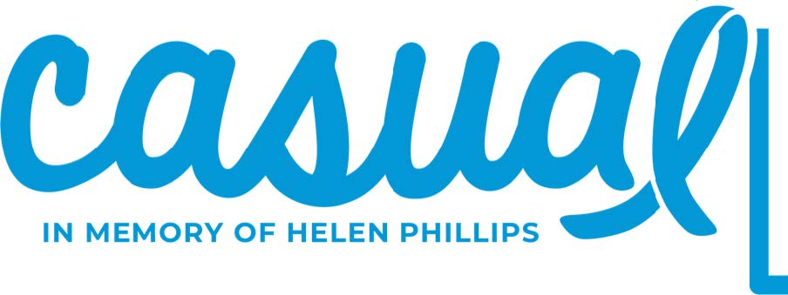
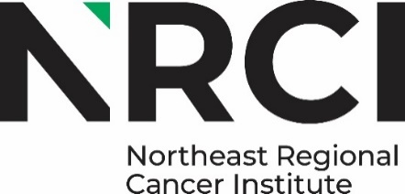

The Northeast Regional Cancer Institute is a 501 (c) (3) non-profit, tax-exempt organization. “A copy of the registration and financial information may be obtained from the Pennsylvania Department of State by calling, toll-free, within Pennsylvania, 1 (800) 732-0999. Registration does not imply endorsement.

December 15, 2025

Dear Friends of NRCI,
On Thursday, March 26, 2026, more than 6,000 people will wear a signature t-shirt and “dress down,” as part of CASUAL Day SM [Colon cancer Awareness Saves Unlimited Adult Lives]. This year’s t-shirt color is Yellow.
We invite you to consider the benefits of sponsoring the 22nd annual event with the knowledge that one hundred percent of proceeds from the event stay in northeast Pennsylvania to support colorectal cancer prevention, early detection education and screenings. Enclosed please find the Sponsorship Opportunities.
Colorectal cancer is one of the most diagnosed cancers in northeast Pennsylvania. The programming focus of the Cancer Institute on this issue- including the wide marketing reach of CASUAL Day SM has resulted in dramatic increases in screening levels. Early diagnosis has helped reduce the pain, suffering and loss of life from colorectal cancers.
Your participation will align you with an extremely important, effective, and visible community effort. Sponsorship information and payment should be submitted to the Cancer Institute by Friday, January 23, 2026.
For more information, please contact NRCI’s Community Relations Coordinator, Amanda at amanda.marchegiani@cancernepa.org or (570) 904-8808.

We thank you in advance for your consideration of this request.
Sincerely,
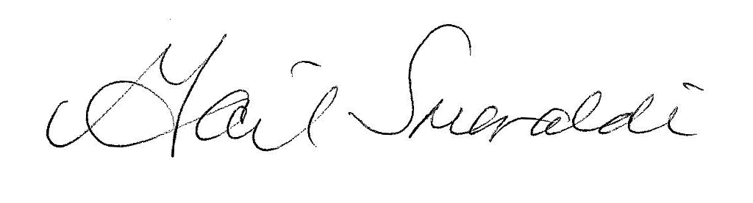 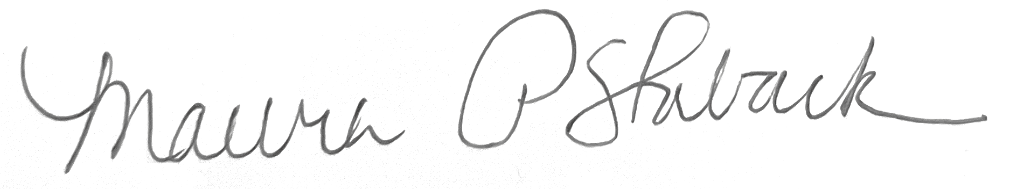
Gail Smeraldi Maura Staback
Co-Chair Founder/ Co-Chair

The Northeast Regional Cancer Institute is a 501 (c) (3) non-profit, tax-exempt organization. “A copy of the registration and financial information may be obtained from the Pennsylvania Department of State by calling, toll-free, within Pennsylvania, 1 (800) 732-0999. Registration does not imply endorsement.

