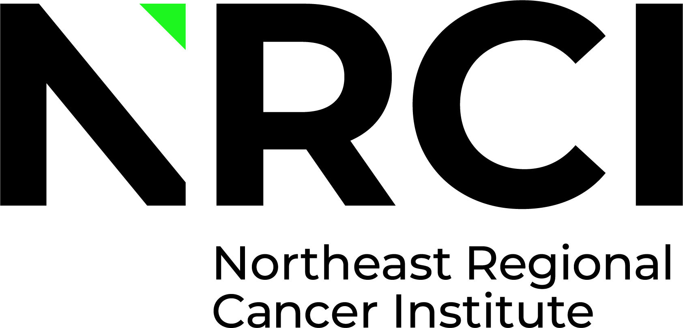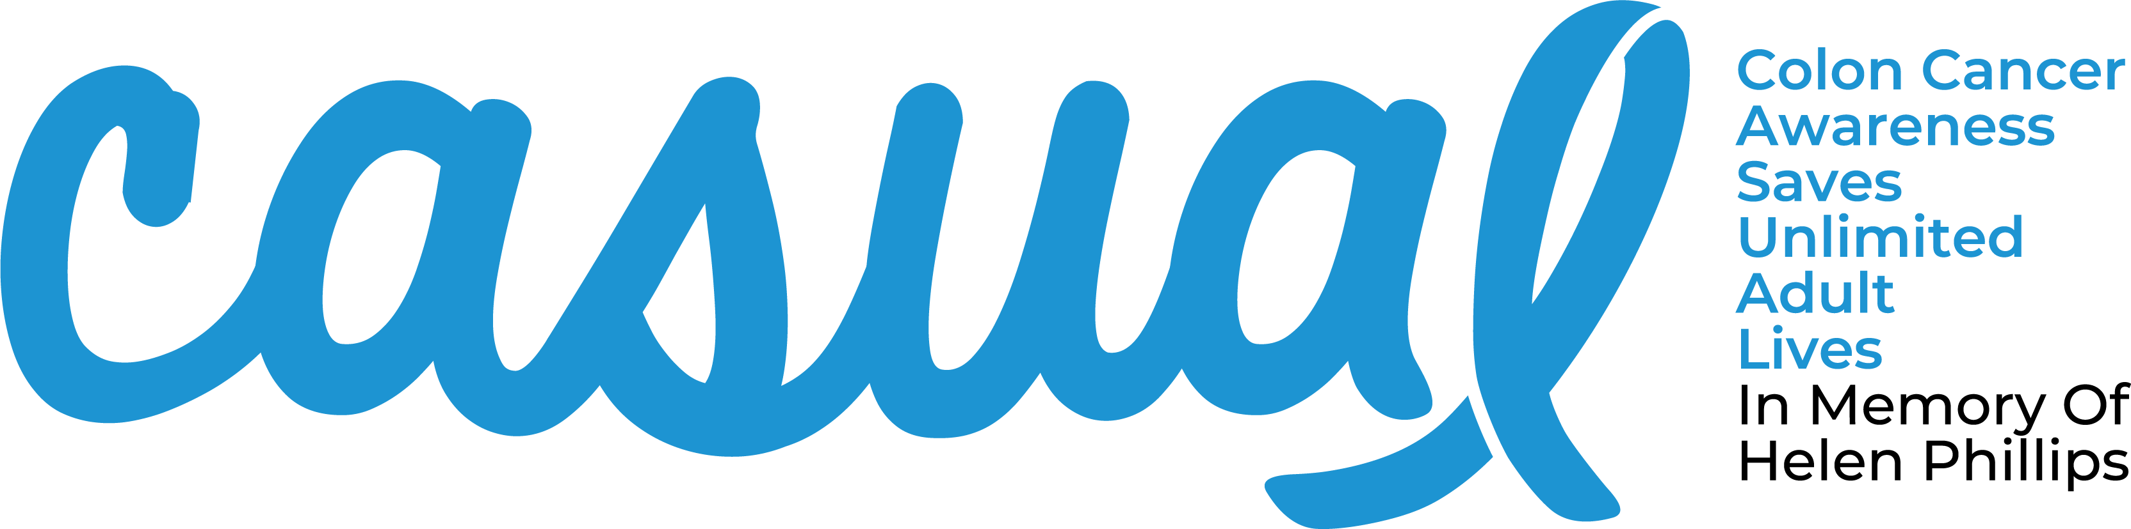

CASUAL Day Sponsorship Commitment Form

Please Fill Out This Form Completely To Ensure That We Accurately Recognize Your Support.

Contact Name:
Company Name:
Address:
Phone Number:
Email Address:
Name of Company/Contributor (as it should appear in promotional materials)
_________________________________________________________________________

Sponsorship Levels: * Please designate shirt styles below (short or long sleeve)
$7,500 – Circle of Hope
I would like the following sizes (S-4XL) for my 20 complimentary shirts:___________

$5,000 – Circle of Courage
I would like the following sizes (S-4XL) for my 16 complimentary shirts:______________

$2,500 – Circle of Support
I would like the following sizes (S-4XL) for my 12 complimentary shirts:______________

$1,000 – Circle of Faith
I would like the following sizes (S-4XL) for my 4 complimentary shirts:______________

$500 – Circle of Inspiration
I would like the following sizes (S-4XL) for my 2 complimentary shirts:______________

$250 -Circle of Friends
I would like the following size (S-4XL) for my 1 complimentary shirt:______________

Please contact the Cancer Institute at (570) 904-8808 if you need additional information.
For $1,000 levels and above, please send your high resolution company logo in pdf, ai, or eps format to amanda.marchegiani@cancernepa.org no later than Friday, January 24, 2024.
Please make check payable to the Northeast Regional Cancer Institute.
Please send this completed form along with your check to:
Northeast Regional Cancer Institute
Attn: CASUAL Day
312 Adams Avenue
Scranton, PA 18503

