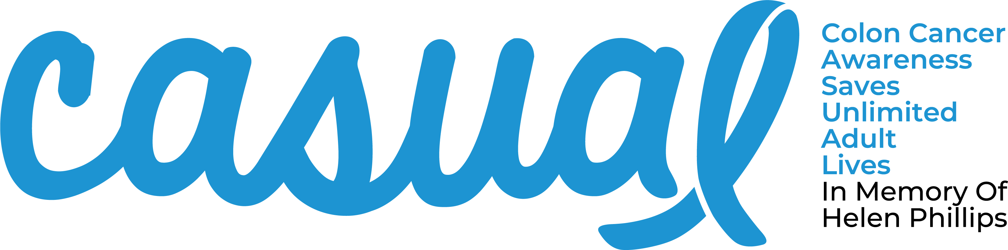
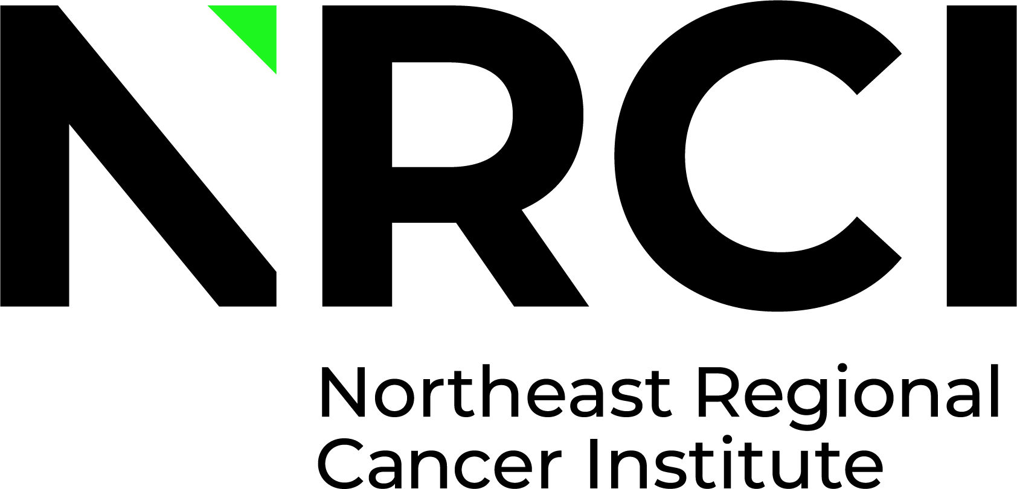

Sponsorship Opportunities

To be recognized on the T-shirt, you must submit your Sponsorship
Commitment Form by Friday, January 19, 2024.
Sponsorships are accepted up to the day of the event.
Circle of Hope Level $7,500 (Exclusive Sponsorship Opportunity)
- Premier Logo (size and location) on CASUAL Day T-shirts
- Recognition as a sponsor for all Cancer Institute events in 2023
- Logo on CASUAL Day specific paid print media
- Recognition at CASUAL Day sponsored events
- Logo on CASUAL Day flyers, posters, & event signage
- Logo on Cancer Institute event web page
- 10 L/S T-Shirts, 10 S/S T-Shirts
Circle of Courage Level $5,000
- Logo on CASUAL Day T-shirts
- Logo on CASUAL Day specific paid print media
- Recognition at CASUAL Day sponsored events
- Logo on CASUAL Day flyers, posters, & event signage
- Logo on Cancer Institute event web page
- 8 L/S T-Shirts, 8 S/S T-Shirts

Circle of Support Level $2,500
- Logo on CASUAL Day T-shirts
- Recognition at CASUAL Day sponsored events
- Logo on CASUAL Day flyers, posters & event signage
- Logo on Cancer Institute event web page
- 6 L/S T-Shirts, 6 S/S T-Shirts

Circle of Faith Level $1,000
- Logo on CASUAL Day T-shirts
- Logo on CASUAL Day flyers, posters & event signage
- Logo on Cancer Institute event web page
- 2 L/S T-Shirts, 2 S/S T-Shirts

Circle of Inspiration Level $500
- Name on CASUAL Day T-shirts
- Name on CASUAL Day flyers, posters & event signage
- Name on Cancer Institute event web page
- 1 L/S T-Shirts, 1 S/S T-Shirts
Circle of Friends Level $250
- Name on Cancer Institute event web page
- 1 T-Shirt

